

**A project report on**

**"Face Recognition Attendance System”**

**Submitted in partial fulfillment of the requirement for the award of**

**DIPLOMA IN**

**Computer Engineering**

**by**

**Amisha Pupala**

**Mokshada Godase**

**Pratiksha Kharatkar**

**Pratiksha Batwal**

**Under the guidance of**

**Prof. Mayur Bhosale**



**DEPARTMENT OF INFORMATION TECHNOLOGY**

**DR. D. Y. PATIL POLYTECHNIC**

**Dr. D. Y. Patil Vidyanagar, Sector-7, Nerul, Navi Mumbai – 400706**

**Academic Year 2017 – 2018**

**CERTIFICATE**

**This is to certify that the report on project entitled**

**" Face Recognition Attendance System”**

**has been successfully completed and submitted by**

**NAME ROLL NO SEATNO**

Amisha Pupala 48 (_________)

Mokshada Godase 34 (_________)

Pratiksha Kharatkar 44 (_________)

Pratiksha Batwal 40 (_________)

for the partial fulfillment of the requirement for the award of Diploma Course in Information Technology as laid down by **Maharashtra State Board of Technical Education** for the academic year **2017 – 2018.**

**During the project they have maintained regular attendance and have worked sincerely.**

**(_______________) (_______________) (_______________) (Prof. M. Bhosale) (Prof. U. Patil) (Prof. S.G. Pathak)**

**PROJECT GUIDE H.O.D PRINCIPAL**

**(_______________) (_______________)**

**INTERNAL EXAMINER EXTERNAL EXAMINER**

**ACKNOWLEDGEMENT**

Working on this project on “Face Detection and Recognition for Automatic Attendance System” was a source of immense knowledge to us It’s a great pleasure and moment of immense satisfaction for us to express our profound gratitude to our guide **Mr. Mayur Bhosale,** whose constant encouragement enabled us to work enthusiastically. His perpetual motivation, patience and excellent expertise in the discussion during progress of the project work have benefited us to an extent, which is beyond expression. We would also like to give my sincere thanks to **Prof. Umesh Patil**, **Head of** **Department,** from DepartmentInformation Technology**,** Dr. D.Y. Patil Polytechnic, Nerul, Navi Mumbai for his guidance, encouragement and support during the seminar. We are also thankful to **Prof. S. G. Pathak, Principal**, Dr. D.Y. Patil Polytechnic, Nerul, Navi Mumbai for providing an outstanding academic environment, also for providing the adequate facilities. We acknowledge with a deep sense of gratitude, the encouragement and inspiration received from our faculty members and colleagues.

**INDEX**

|  |  |  |
| --- | --- | --- |
| **SR NO** | **NAME** | **PAGE NO** |
| 01 | ABSTRACT | 1 |
| 02 | INTRODUCTION | 3 |
| 03 | LITERATURE SURVEY | 5 |
| 04 | PROBLEM DEFINITION |  |
| 05 | PROPOSED SYSTEM |  |
| 06 | REQUIREMENTS | 9 |
| 07 | BLOCK DIAGRAM | 11 |
| 08 | UML DIAGRAMS | 13 |
| 09 | IMPLEMENTATION | 15 |
| 10 | DATA FLOW DIAGRAM | 17 |
| 11 | UNIQUENESS OF THE TOPIC | 19 |
| 12 | MERITS AND DEMERITS | 21 |
| 13 | SCREENSHOTS | 23 |
| 14 | CONCLUSION | 25 |
| 15 | FUTURE SCOPE | 27 |
| 16 | REFERENCES | 29 |

**CHAPTER-1**

**ABSTRACT**

**ABSTRACT**

The face is the identity of a person. The methods to exploit this physical feature have seen a great change since the advent of image processing techniques. The accurate recognition of a person is the sole aim of a face recognition system and this identification maybe used for further processing. We propose a framework that takes the participation of students for classroom lecture. The proposed system framework takes the participation naturally utilizing face identification and recognition. This participation is recorded by utilizing a camera connected as a part of front of classroom that is continuously catching pictures of students, detect the faces in image and contrast the distinguished appearances and the database and mark the attendance. This paper describes the working of the face recognition system that will be deployed as an Automated Attendance System in a classroom environment.

**CHAPTER-2**

**INTRODUCTION**

**INTRODUCTION**

Face Recognition as it is often referred to as, analyses characteristics of a person's face image input through a camera. Facial recognition or face recognition as it is often referred to as, analyses characteristics of a person's face image input through a camera. Verification or identification can be accomplished from two feet away or more, without requiring the user to wait for long periods of time or do anything more than look at the camera. Maintaining the attendance is very important in all the institutes for checking the performance of employees. Every institute has its own method in this regard. Some are taking attendance manually using the old paper or file based approach and some have adopted methods of automatic attendance using some biometric techniques. But in these methods employees have to wait for long time in making a queue at time they enter the office. Biometric recognition has the potential to become an irreplaceable part of many identification systems used for evaluating the performance of those people working within the organization. Although biometric technologies are being applied in many fields it has not yet delivered its promise of guaranteeing automatic human recognition. Face recognition is a technique of biometric recognition. It is considered to be one of the most successful applications of image analysis and processing; that is the main reason behind the great attention it has been given in the past several years Many biometric systems are available but the key authentications are same is all the techniques. Every biometric system consists of enrolment process in which unique features of a person is stored in the database and then there are processes of identification and verification. These two processes compare the biometric feature of a person with previously stored template captured at the time of enrollment. Biometric templates can be of many types like Fingerprints, Eye Iris, Face, Hand Geometry, Signature, Gait and voice. Our system uses the face recognition approach for the automatic attendance of employees in the office room environment without employees’ intervention . Face recognition consists of two steps, in first step faces are detected in the image and then these detected faces are compared with the database for verification.

**CHAPTER-3**

**LITERATURE SURVEY**

**Literature Survey**

* 1. **Biometrics:**

Biometrics is the automated recognition of individuals based on their behavioral or physiological characteristics .The physiological characteristics are related to the shape of the body. The most common example is fingerprint. Other examples include face recognition, hand geometry and iris recognition. The behavioral characteristics are related to the behavior of a person. Signature is one example of these characteristics which is still widely used today.

With the rapid development in the field of pattern recognition and its uses in different areas e.g. (signature recognition, facial recognition), arises the importance of the utilization of this technology in different areas in large organizations. This is mainly because these applications help the top-management take decisions that improve the performance and effectiveness of the organization. On the other hand, for an organization to be effective, it needs accurate and fast means of recording the performance of the people inside this organization. Biometric recognition has the potential to become an irreplaceable part of many identification systems used for evaluating the performance of those people working within the organization. Although biometric technologies are being applied in many fields it has not yet delivered its promise of guaranteeing automatic human recognition. This research is the first of its kind to attempt to provide an automated attendance system that recognizes students using face recognition technology through an image/video stream to record their attendance in lectures or sections and evaluating their performance accordingly.

* 1. **Facial Recognition**

Facial recognition (or face recognition) is a [biometric](http://searchsecurity.techtarget.com/definition/biometrics) method of identifying an individual by comparing [live capture](http://searchsecurity.techtarget.com/definition/live-capture) or digital image data with the stored record for that person. Most current facial recognition systems work with numeric codes called face prints. Such systems identify 80 nodal points on a human face. In this context, nodal points are end points used to measure variables of a person’s face, such as the length or width of the nose, the depth of the eye sockets and the shape of the cheekbones. These systems work by capturing data for nodal points on a digital image of an individual’s face and storing the resulting data as a face print. The face print can then be used as a basis for comparison with data captured from faces in an image or video.

Facial recognition systems based on face prints can quickly and accurately identify target individuals when the conditions are favorable. However, if the subject’s face is partially obscured or in profile rather than facing forward, or if the light is insufficient, the software is less reliable. Nevertheless, the technology is evolving quickly and there are several emerging approaches, such as [3D modeling](http://whatis.techtarget.com/definition/3D-modeling), that may overcome current problems with the systems.

**Techniques for feature extraction**

Face recognition compared to image processing is far more complex and there are several techniques in use today as listed below. Note: some methods are very old but the intuition behind them might come in handy.

1. **Graph matching**: In [Elastic Bunch Graph Matching](http://www.face-rec.org/algorithms/ebgm/wisfelkrue99-facerecognition-jainbook.pdf) a set of Gabor filters is used to construct an image graph of a face and face recognition is done by a straight forward matching of the graphs.
2. **Template matching:** [Face recognition using genetic algorithm based template matching](http://ieeexplore.ieee.org/xpl/login.jsp?arnumber=1413920&tp=&url=http%3A%2F%2Fieeexplore.ieee.org%2Fxpls%2Fabs_all.jsp%3Farnumber%3D1413920) can work remarkably well when implemented properly as earlier template based approaches were not practical due to severe variations between faces of the same person.
3. **Neural Networks:** [Face recognition using Neural networks](http://neuroph.sourceforge.net/tutorials/FaceRecognition/FaceRecognitionUsingNeuralNetwork.html) can range from full-face processing to face-landmark based processing. The full-face recognition approach involves having a large amount of the individual face images from a single person. The trick is to train the network to fire correctly when a particular face is presented using the usual backprop algorithm. In the landmark based approach part detector neural nets are trained on face landmarks such as right eye, left eye etc. and the final detection or recognition is based partly on the geometric relationship between the landmarks. You can also check [face detection](https://courses.cs.washington.edu/courses/cse577/05sp/papers/rowley.pdf)  using neural nets.
4. **Deep learning:** The area of deep learning involves learning richer, high-level abstract features from the training set before using a final classifier back-end. The convolutional nets are state-of-the-art in areas such as category-level object recognition systems including face recognition.
5. **3D based:** 3D techniques such those applied in Microsoft's Windows involves modeling a face in 3D from one or more face shots. Ideally it is required to obtain such a representation from one shot as done in Deep Face. The subsequent processing routines can then process the face from a canonical representation hence this helps the face recognizer system handle severe view point variations.
   1. **Face Recognition Process:-**

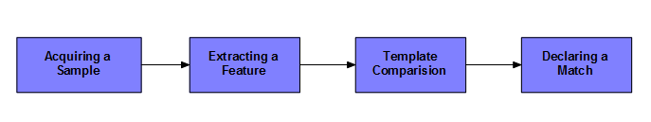

**3.3.1 Acquiring a sample:** In a complete, full implemented biometric system, a sensor takes an observation. The sensor might be a camera and the observation is a snapshot picture. In our system, a sensor will be ignored, and a 2D face picture “observation” will supplied manual

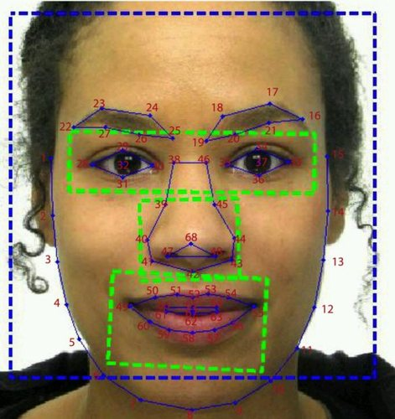

**Fig3.1: Acquiring a sample**

**3.3.2 Extracting Features:** For this step, the relevant data is extracted from the predefined captured sample. This is can be done by the use of software where many algorithms are available. The outcome of this step is a biometric template which is a reduced set of data that represents the unique features of the enrolled user's face.

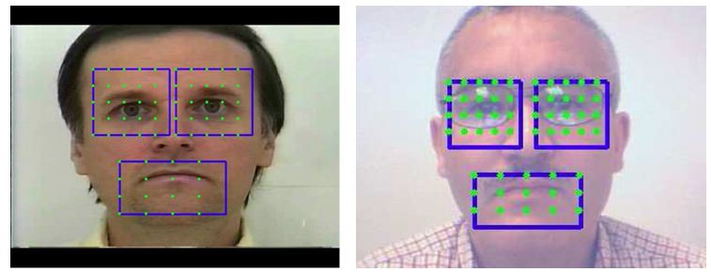

**Fig3.2: Extracting Features**

**3.3.3 Comparison Templates:** This depends on the application at hand. For identification purposes, this step will be a comparison between a given picture for the subject and all the biometric templates stored on a database. For verification, the biometric template of the claimed identity will be retrieved (either from a database or a storage medium presented by the subject) and this will be compared to a given picture.

**3.3.4 Declaring a Match:** The face recognition system will return a candidate match list of potential matches. In this case, the intervention of a human operator will be required in order to select the best fit from the candidate list. An illustrative analogy is that of a walk-through metal detector, where if a person causes the 7 detector to beep, a human operator steps in and checks the person manually or with a hand-held detector.

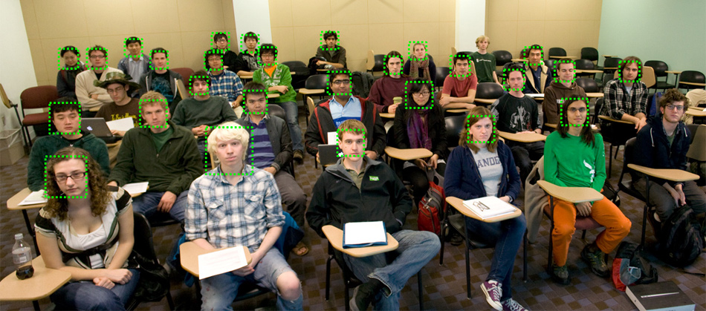

**Fig3.3: Declaring a Match**

* This code is supposed to grab live camera feed, display feed in a window, mark in rectangles all detected faces, get the biggest detected face (by total area), display it in separate window, convert it to grayscale and finally save as PNG to hard disk, in project directory
* It is a fast, accurate and reliable than any other existing method.
* Face recognition is easy to use and in many cases it can be performed without person even knowing.
* Face recognition is also one of the most inexpensive biometric in the market and its price should continue to go down.
* There are many benefits to face recognition system such as its convinence and social acceptability
* Security counterterrorism: Access control comparing surveillance images to know terrorist.
* Immigration rapid progression through customs
* Banking using ATM the software is able to quickly verify a customer face
* Physical access control of building areas, doors or net acces

Image processing is the process of manipulating image data in order to make it suitable for computer vision applications or to make it suitable to present it to humans. For example, changing brightness or contrast  is a image processing task which make the image visually pleasing for humans or suitable for further processing for a certain computer vision application.

Computer vision which go beyond image processing, helps to obtain relevant information from images and make decisions based on that information. In other words, computer vision is making the computer see as humans do. Basic steps for a typical computer vision application as follows.

1. Image acquisition
2. Image manipulation
3. Obtaining relevant information
4. Decision making

If you are new to computer vision, you may be wondering where to start. First you have to understand the basic principles of image processing and computer vision. Then you have to choose a suitable language to develop your computer vision application. Some of the most popular methods are using OpenCV with C/C++. If you don't really know why you would choose one over the other, here is my explanation

**CHAPTER-4**

**PROBLEM DEFINITION**

**PROBLEM DEFINITION**

Every time a lecture, section starts the lecturer or teaching .This is a lengthy process and takes a lot of time and effort, especially if it is a lecture with a huge number of students. It also causes a lot of disturbance and interruption when an exam is held. Moreover the attendance sheet is subjected to damage and loss while being passed on between different students or teaching staff. And when the number of students enrolled in a certain course is huge, the doctors tend to call a couple of student names at random which is not a fair student evaluation process either. Finally, these attendance records are used by the staff to monitor the students’ 3 attendance rates. This process could be easy and effective with a small number of students but on the other hand, dealing with the records of a large number of students often leads to human errors.

**CHAPTER-5**

**PROPOSED SYSTEM**

**PROPOSED SYSTEM**

The Proposed system overcomes the problem of the existing system. This project uses the face recognition technique using this student record the attendance.

In the proposed system when student come to the class or lecture system application is start.

It works only is standing in front of the system (Computer application) the application capture the image and send the processing side.

The processing side the application recognize the face of the student.

Finally the application mark as student present. If the face is not recognizing the application make as absent.

**CHAPTER-6**

**REQUIRMENTS**

**REQUIREMENTS**

* HARDWARE REQUIRMENT

1. Processing: 1.66 GHz Pentium Processor or Intel compatible processor.
2. Memory: 2GB RAM
3. 80 GB free Hard Disk space
4. Web camera of Resolution: 512 by 512 pixels.

* SOFTWARE REQUIRMENT1. Visual Studio 2010 (.net framework)

2. My SQL Server 2008

**CHAPTER-7**

**BLOCK DIAGRAM**

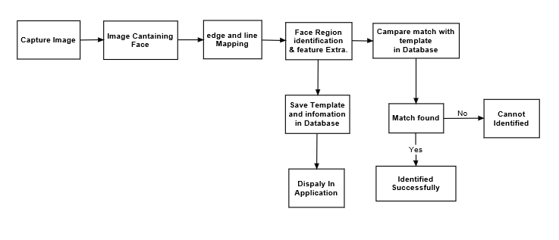**BLOCK DIAGRAM**

**Step1:** Acquiring a sample in a complete, full implemented biometric system, a sensor takes an observation. The sensor might be a camera and the observation is a snapshot picture.

**Step2**: Extracting features for this step, the relevant data is extracted from the predefined captured sample. This is can be done by the use of software where many algorithms are available.

**Step3:** Comparison templates this depends on the application at hand. For identification purposes, this step will be a comparison between a given picture for the subject and all the biometric templates stored on a database.

**Step4:** Declaring a Matchthe face recognition system will return a candidate match list of potential matches. In this case, the intervention of a human operator will be required in order to select the best fit from the candidate list.

**CHAPTER-8**

**UML DIAGRAMS**

**UML DIAGRAMS**

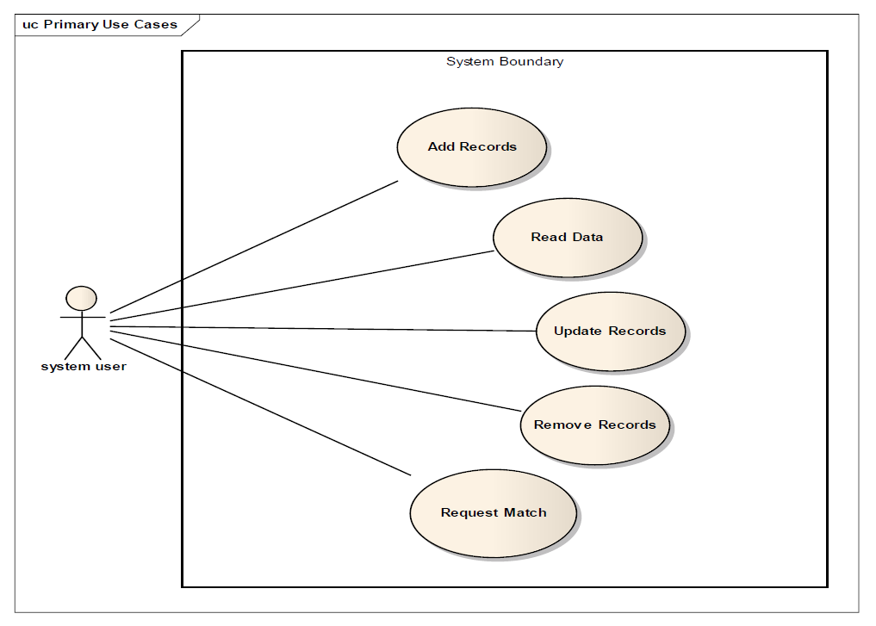

**CHAPTER-9**

**IMPLEMENTATION**

**IMPLEMENTATIONS**

The proposed system plan for an Automatic Attendance System using image processing includes:

>Enrollment of students.

>Capturing the video of students.

>Face detection and feature extraction.

>Face recognition and marketing attendance.

**CHAPTER-10**

**DATA FLOW DIAGRAM (DFD):**

**DATA FLOW DIAGRAM**

**10.1 LEVEL DFD**

This is the 0 level DFD for Data Processing. Here We are selecting all the databases and processing them using system to get the highest profit.

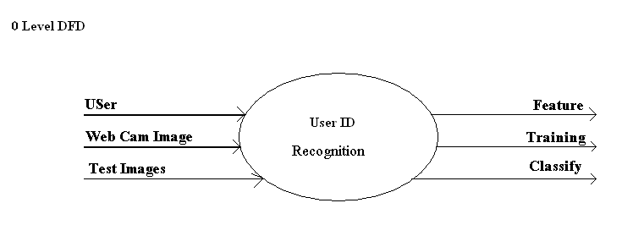Fig10.1:DFD Level 0

**10.2 Level DFD**

This is the level 1DFD in which the different databases such as sales, discount and expenditure details are processed using system and used that result for getting highest profit by applying them to the current year information.

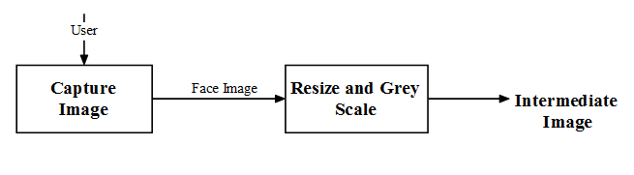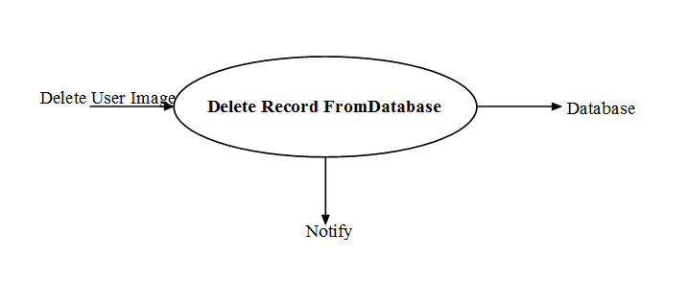

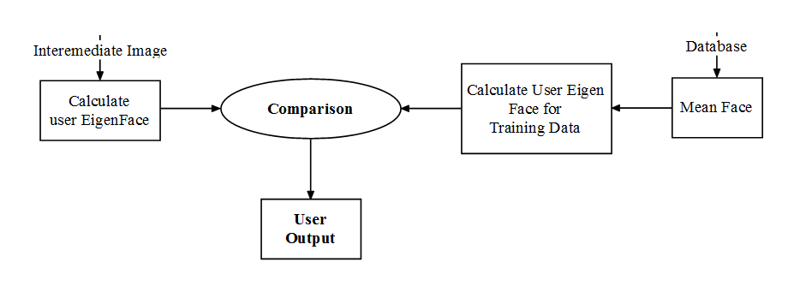

Fig 10.2: DFD Level 1

**10.3 Level 2 DFD**

This level shows a little more detail as compared to level 1. It shows the entire connection which is required for the flow of data from the user to the motors which are responsible for movement of the robot. The input taken from user is sent to the microcontroller. The microcontroller processes this data and makes a decision about the robot movement. This is sent to the motors and causes robot to move towards the destination.

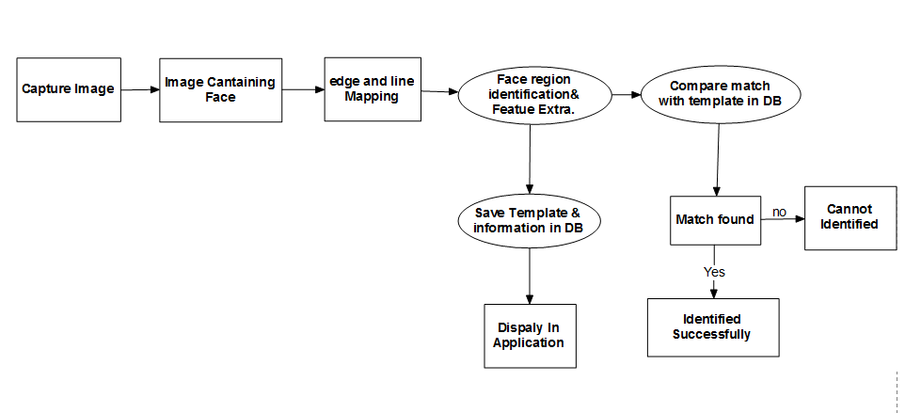Fig 10.3: DFD Level 2

**CHAPTER-11**

**UNIQUENESS OF THE TOPIC**

**UNIQUENESS OF THE TOPIC**

This project serves to automate the prevalent traditional tedious and time wasting methods of marking student attendance in classrooms. The use of automatic attendance through face detection and recognition will increase the effectiveness of attendance monitoring and management.

This method could also be extended for use in examination halls to curb cases of impersonation as the system will be able to single out the imposters who won’t have been captured during the enrollment process. Applications of face recognition are widely spreading in areas such as criminal identification, security systems, image and film processing. The system could also find applications in all authorized access facilities.

**CHAPTER-12**

**MERITS AND DEMERITS**

**MERITS AND DEMERITS**

* **MERITS**

1. Improved security
2. Improved customer experience
3. Cannot be forgotten or lost
4. Reduced operational costs

* **DEMERITS**

1. Environment and usage can affect measurements
2. Systems are not 100% accurate.
3. Require integration and/or additional hardware
4. Cannot be reset once compromised

**CHAPTER-13**

**SCREENSHOTS**

**SCREENSHOTS** 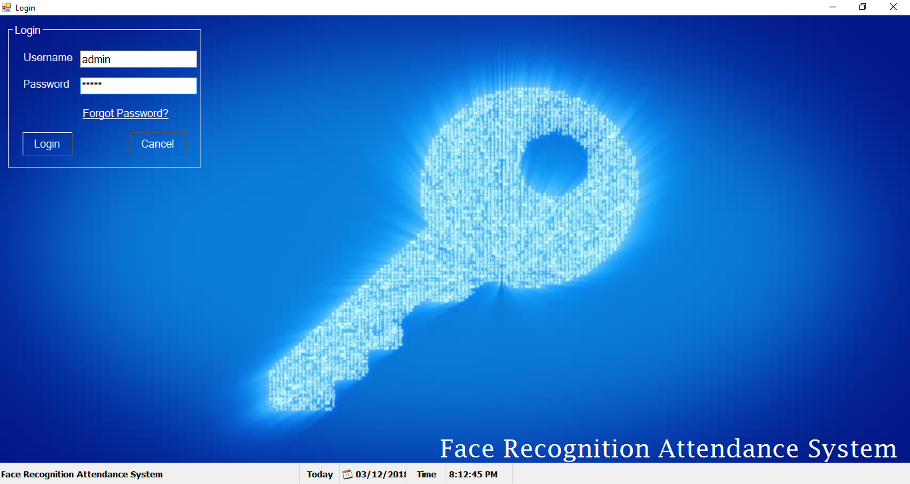

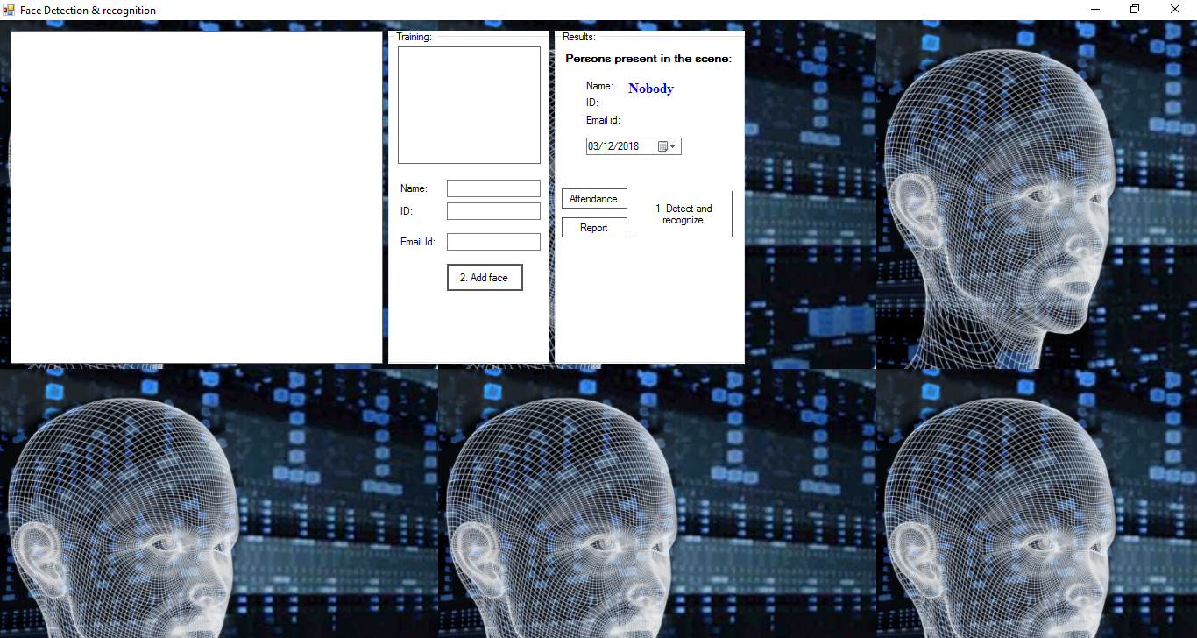 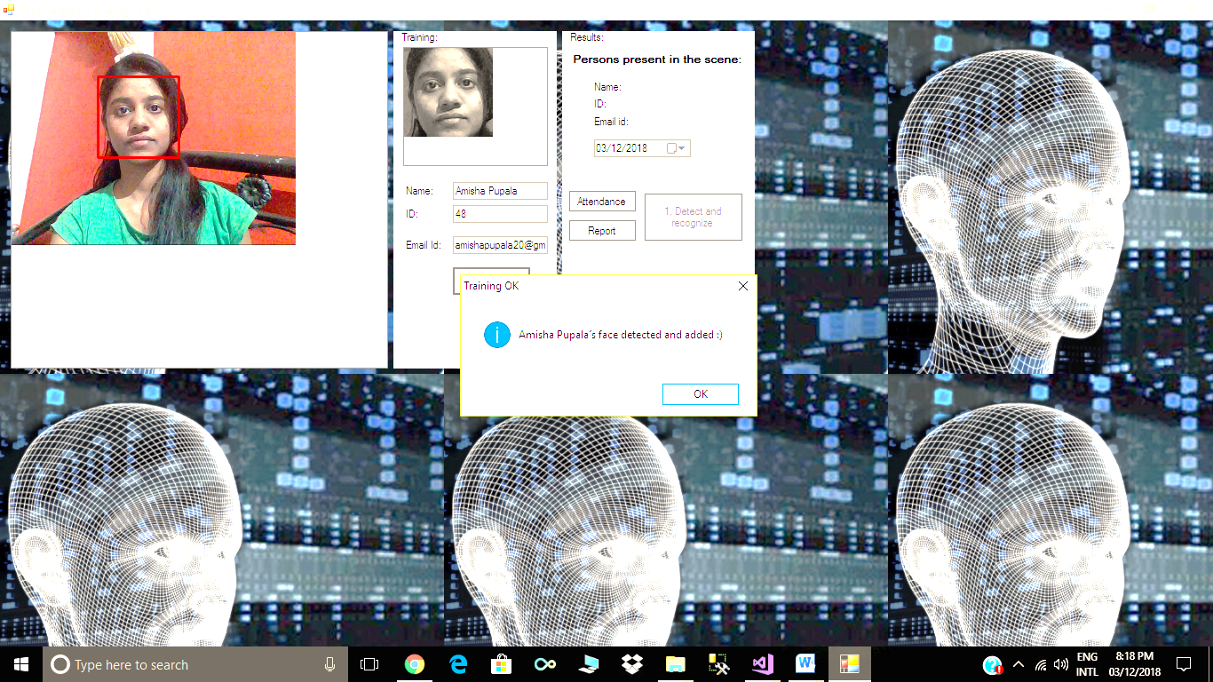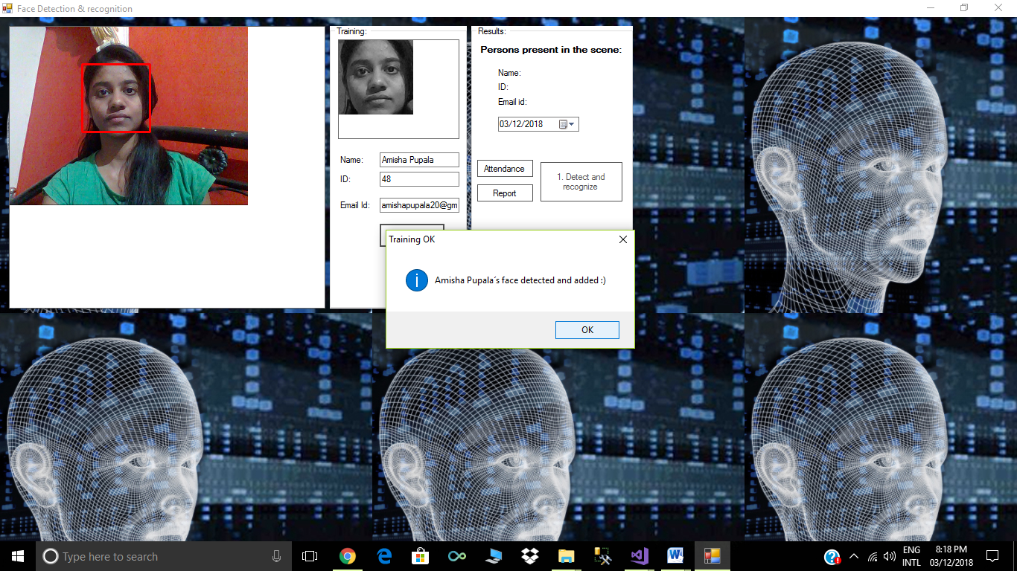 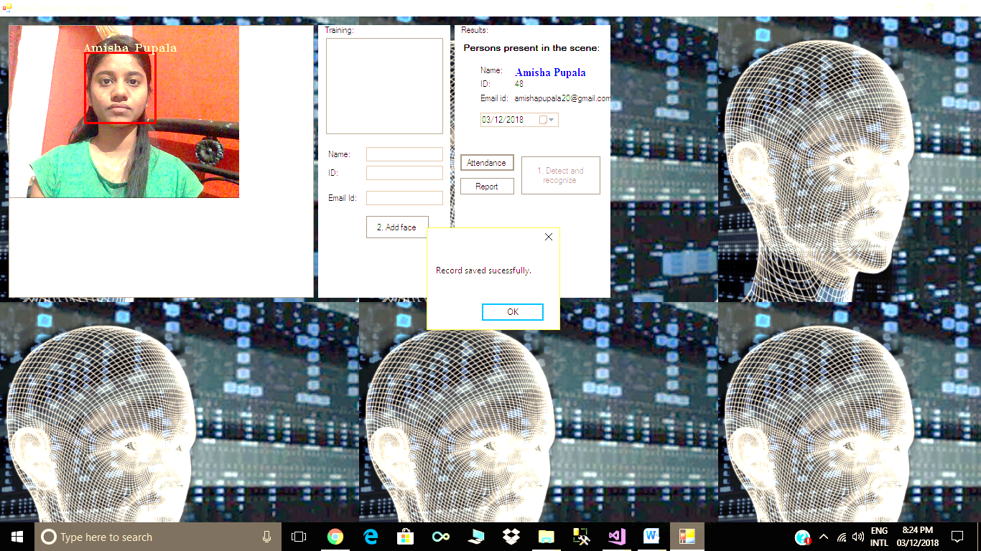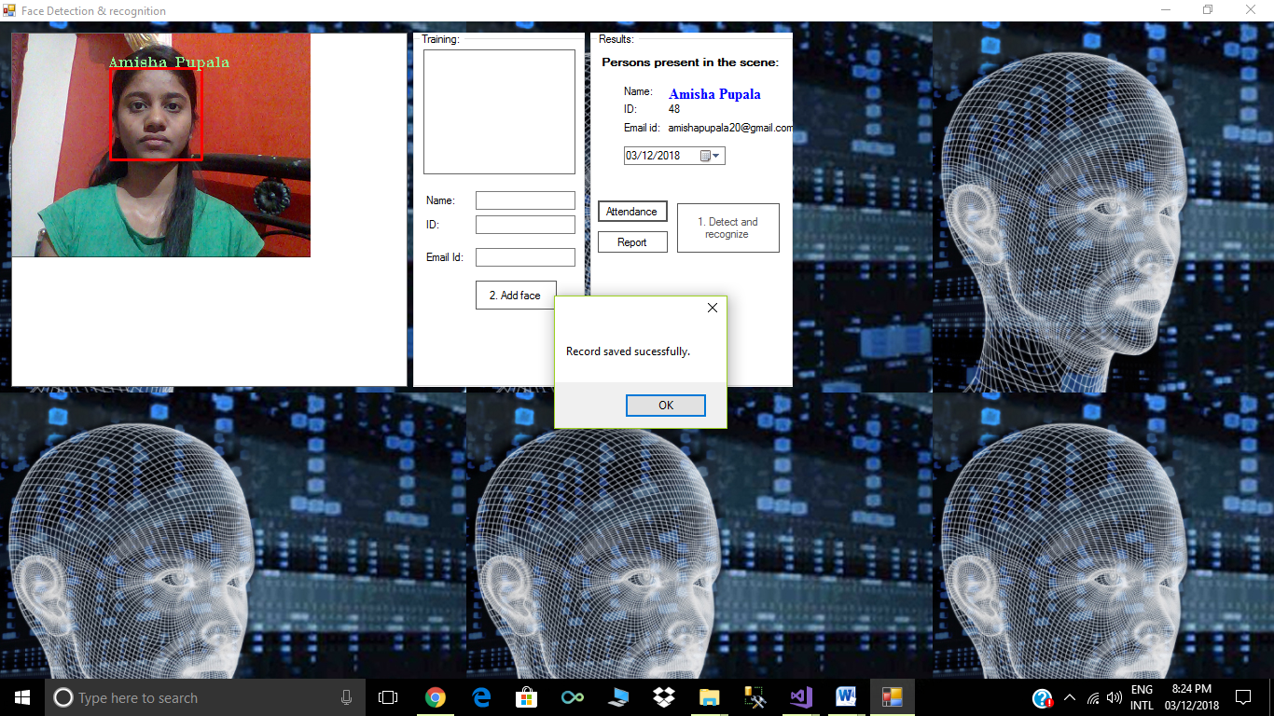

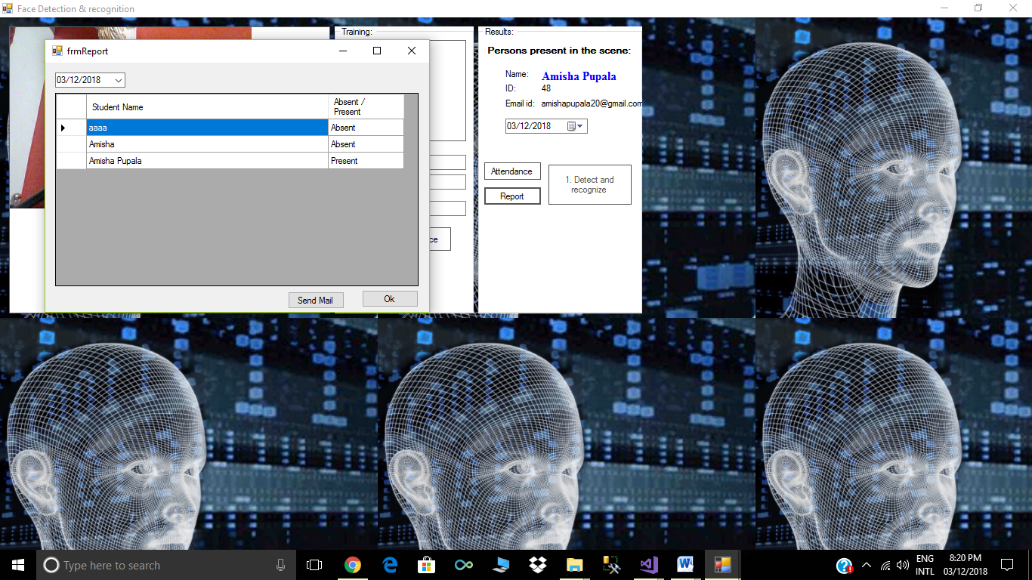

**CHAPTER-14**

**CONCLUSION**

**CONCLUSION**

It can be concluded from the above dialogue that a dependable, secure, rapid and an efficient system has been evolved changing a guide and an unreliable system. This process can be carried out for higher outcomes regarding the control of attendance. This system will keep time, reduce the quantity of work the administration has to do and will update stationary material with digital apparatus .Every other application of this machine is that it is capable of marking the presence of personnel at any place of work and this attendance will be useful for calculating their month to month payment.

**CHAPTER-15**

**FUTURE SCOPE**

**FUTURE SCOPE**

The system we have developed has successfully able to accomplish the task of making the attendance in the classroom automatically and output obtained in an excel sheet as desired in real time. Another important aspect where we can work is towards creating an online data base of the attendance and its automatic updating, keeping in mind growing popularity of internet of things. The scope of the project is the system on which the software is installed, i.e. the project is developed as a desktop application, and it will work for a particular institute. But later on the project can be modified to operate it online. Again we can update the system in such a way that if the student is absent on a particular day then via mail the parents will automatically informed. Face recognition systems used today work very well under constrained conditions, although all systems work much better with frontal mug-shot images and constant lighting. All current face recognition algorithms fail under the vastly varying conditions under which humans need to and are able to identify other people. Next generation person recognition systems will need to recognize people in real-time and in much less constrained situations.

**CHAPTER-16**

**REFERENCE**

**REFERENCE**

Sites referred for the project are as follows:

<https://mail.google.com/mail/u/0/#inbox/15e815608ba639d6?projector=1>

<https://www.researchgate.net/profile/Tetsuo_Shoji2/publication/241608617_Face_Recognition-based_Lecture_Attendance_System/links/54418ff00cf2a76a3cc82282/Face-Recognition-based-Lecture-Attendance-System.pdf>

https://www.quora.com/What-are-techniques-used-for-facial-recognition-and-image-processing

<https://www.ncbi.nlm.nih.gov/pubmed/8027706>

Books referred for the project are as follows :

* W. Zhao, R. Chellappa, P. J. Phillips, and A. Rosenfeld,“Face recognition: A literature survey,” ACM Computing Surveys, 2003, vol. 35, no. 4, pp. 399-458.
* Herbert Bay, Andreas Ess, TinneTuytelaars, and Luc Van Gool. Surf: Speeded up robust features. Computer Vision and Image Understanding (CVIU), 110(3):346–359.
* H.K.Ekenel and R.Stiefelhagen,Analysis of local appearance based face recognition: Effects of feature selection and feature normalization. In CVPR Biometrics Workshop, New York, USA, 2016

**APPENDIX**

**APPENDIX**

**Form:1**

using System;

using System.Collections.Generic;

using System.ComponentModel;

using System.Data;

using System.Drawing;

using System.Linq;

using System.Text;

using System.Windows.Forms;

using System.Data.Sql;

using System.Data.SqlClient;

namespace MultiFaceRec

{

public partial class Form1 : Form

{

public Form1()

{

InitializeComponent();

}

int count =1;

private void button1_Click(object sender, EventArgs e)

{

if(count==3)

{

MessageBox.Show("Your attempts exceded. Restart Application ", "Face Recognition Attendence System", MessageBoxButtons.OK, MessageBoxIcon.Warning);

button1.Enabled = false;

}

if (UsernameTextBox.Text == "" || PasswordTextBox.Text == "")

{

count++;

if (UsernameTextBox.Text =="")

{

MessageBox.Show("Please Enter User Name","Face Recognition Attendence System",MessageBoxButtons.OK,MessageBoxIcon.Warning);

UsernameTextBox.Focus();

}

if(PasswordTextBox.Text=="")

{

MessageBox.Show("Please Enter Password", "Face Recognition Attendence System", MessageBoxButtons.OK, MessageBoxIcon.Warning);

PasswordTextBox.Focus();

}

return;

}

if (UsernameTextBox.Text != "admin" || PasswordTextBox.Text != "admin")

{

count++;

MessageBox.Show("Invalid User Name or Password", "Face Recognition Attendence System", MessageBoxButtons.OK, MessageBoxIcon.Warning);

UsernameTextBox.Text = "";

PasswordTextBox.Text = "";

UsernameTextBox.Focus();

return;

}

this.Hide();

FrmPrincipal fp = new FrmPrincipal();

fp.Show();

}

private void PasswordTextBox_TextChanged(object sender, EventArgs e)

{

}

private void tmr_SB_Tick(object sender, EventArgs e)

{

SBP3_Date.Text = DateTime.Today.ToString();

SBP5_Showtime.Text = DateTime.Now.ToLongTimeString();

}

private void Form1_Load(object sender, EventArgs e)

{

}

private void button2_Click(object sender, EventArgs e)

{

this.Close();

}

}

}

**Mainform:**

using System;

using System.Configuration;

using System.Collections.Generic;

using System.Drawing;

using System.IO;

using System.Threading;

using System.Windows.Forms;

using Emgu.CV;

using Emgu.CV.CvEnum;

using Emgu.CV.Structure;

using System.Data.Sql;

using System.Data.SqlClient;

using System.Data;

namespace MultiFaceRec

{

public partial class FrmPrincipal : Form

{

//Declararation of all variables, vectors and haarcascades

Image<Bgr, Byte> currentFrame; //to store image or current frame

Capture grabber; // object for camera

HaarCascade face; // Haar classifier

HaarCascade eye;

MCvFont font = new MCvFont(FONT.CV_FONT_HERSHEY_TRIPLEX, 0.5d, 0.5d);

Image<Gray, byte> result, TrainedFace = null;

Image<Gray, byte> gray = null;

List<Image<Gray, byte>> trainingImages = new List<Image<Gray, byte>>();

List<string> labels = new List<string>();

List<string> NamePersons = new List<string>();

int ContTrain, NumLabels, t;

string name, names = null;

string dat1, dat2, dat3;

String strConnectionString = ConfigurationManager.ConnectionStrings["myConnectionString"].ConnectionString;

public FrmPrincipal()

{

InitializeComponent();

//Load haarcascades for face detection

face = new HaarCascade("haarcascade_frontalface_default.xml");

// eye = new HaarCascade("haarcascade_eye.xml");

try

{

//Load of previus trainned faces and labels for each image

string Labelsinfo = File.ReadAllText(Application.StartupPath + "/TrainedFaces/TrainedLabels.txt");

string[] Labels = Labelsinfo.Split('%');

NumLabels = Convert.ToInt16(Labels[0]);

ContTrain = NumLabels;

string LoadFaces;

for (int tf = 1; tf < NumLabels + 1; tf++)

{

LoadFaces = "face" + tf + ".bmp";

trainingImages.Add(new Image<Gray, byte>(Application.StartupPath + "/TrainedFaces/" + LoadFaces));

labels.Add(Labels[tf]);

}

}

catch (Exception e)

{

//MessageBox.Show(e.ToString());

MessageBox.Show("Nothing in binary database, please add at least a face(Simply train the prototype with the Add Face Button).", "Triained faces load", MessageBoxButtons.OK, MessageBoxIcon.Exclamation);

}

}

private void button1_Click(object sender, EventArgs e)

{

//Initialize the capture device

grabber = new Capture();

grabber.QueryFrame();

//Initialize the FrameGraber event

Application.Idle += new EventHandler(FrameGrabber);

button1.Enabled = false;

}

private void button2_Click(object sender, System.EventArgs e)

{

try

{

if ((textBox1.Text != "") || (textBox2.Text != "") || (textBox3.Text != ""))

{

//Trained face counter

ContTrain = ContTrain + 1;

//Get a gray frame from capture device

gray = grabber.QueryGrayFrame().Resize(320, 240, Emgu.CV.CvEnum.INTER.CV_INTER_CUBIC);

//Face Detector

MCvAvgComp[][] facesDetected = gray.DetectHaarCascade(

face,

1.2,

10,

Emgu.CV.CvEnum.HAAR_DETECTION_TYPE.DO_CANNY_PRUNING,

new Size(20, 20));

//Action for each element detected

foreach (MCvAvgComp f in facesDetected[0])

{

TrainedFace = currentFrame.Copy(f.rect).Convert<Gray, byte>();

break;

}

//resize face detected image for force to compare the same size with the

//test image with cubic interpolation type method

TrainedFace = result.Resize(100, 100, Emgu.CV.CvEnum.INTER.CV_INTER_CUBIC);

trainingImages.Add(TrainedFace);

string user_data;

user_data = textBox1.Text + ";" + textBox2.Text + ";" + textBox3.Text;

labels.Add(user_data);

//Show face added in gray scale

imageBox1.Image = TrainedFace;

//Write the number of triained faces in a file text for further load

File.WriteAllText(Application.StartupPath + "/TrainedFaces/TrainedLabels.txt", trainingImages.ToArray().Length.ToString() + "%");

//Write the labels of triained faces in a file text for further load

for (int i = 1; i < trainingImages.ToArray().Length + 1; i++)

{

trainingImages.ToArray()[i - 1].Save(Application.StartupPath + "/TrainedFaces/face" + i + ".bmp");

File.AppendAllText(Application.StartupPath + "/TrainedFaces/TrainedLabels.txt", labels.ToArray()[i - 1] + "%");

}

String strCommandText;

strCommandText = "Insert Into [Student] ([StudentName], [StudentID], [Email_id]) Values ('" + textBox1.Text + "', '" + textBox2.Text + "' ,'" + textBox3.Text + "' )";

// System.Data.OleDb.SqlCommand objSqlCommand = new System.Data.OleDb.SqlCommand();

SqlCommand objSqlCommand = new SqlCommand();

try

{

// objSqlCommand.Connection = new System.Data.OleDb.OleDbConnection(strConnectionString);

objSqlCommand.Connection = new SqlConnection(strConnectionString);

//if (objSqlCommand.Connection.State == System.Data.ConnectionState.Closed)

//{

// objSqlCommand.Connection.Open();

//}

if(objSqlCommand.Connection.State==ConnectionState.Closed)

{

objSqlCommand.Connection.Open();

}

//objSqlCommand.CommandText = strCommandText;

//objSqlCommand.CommandType = System.Data.CommandType.Text;

//objSqlCommand.ExecuteNonQuery();

objSqlCommand.CommandText = strCommandText;

objSqlCommand.CommandType = CommandType.Text;

objSqlCommand.ExecuteNonQuery();

MessageBox.Show("Record saved sucessfully.");

}

catch (Exception ex)

{

if (objSqlCommand.Connection.State == ConnectionState.Open)

{

objSqlCommand.Connection.Close();

}

//MessageBox.Show("Error while saving the record.");

}

MessageBox.Show(textBox1.Text + "´s face detected and added :)", "Training OK", MessageBoxButtons.OK, MessageBoxIcon.Information);

textBox1.Text = "";

textBox2.Text = "";

textBox3.Text = "";

imageBox1.Image = null;

}

else

{

MessageBox.Show("Failed", "Training Fail", MessageBoxButtons.OK, MessageBoxIcon.Exclamation);

}

}

catch

{

MessageBox.Show("Enable the face detection first", "Training Fail", MessageBoxButtons.OK, MessageBoxIcon.Exclamation);

}

}

private void imageBoxFrameGrabber_Click(object sender, EventArgs e)

{

}

private void label10_Click(object sender, EventArgs e)

{

}

private void imageBox1_Click(object sender, EventArgs e)

{

}

private void textBox1_TextChanged(object sender, EventArgs e)

{

}

void FrameGrabber(object sender, EventArgs e)

{

Thread.Sleep(300);

label3.Text = "0";

//label4.Text = "";

NamePersons.Add("");

//Get the current frame form capture device

currentFrame = grabber.QueryFrame().Resize(320, 240, Emgu.CV.CvEnum.INTER.CV_INTER_CUBIC);

//Convert it to Grayscale

gray = currentFrame.Convert<Gray, Byte>();

//Face Detector

MCvAvgComp[][] facesDetected = gray.DetectHaarCascade(

face,

1.2,

10,

Emgu.CV.CvEnum.HAAR_DETECTION_TYPE.DO_CANNY_PRUNING,

new Size(20, 20));

int num_faces;

num_faces = facesDetected.GetLength(0);

if (num_faces <= 1)

{

//Action for each element detected

foreach (MCvAvgComp f in facesDetected[0])

{

if (num_faces <= 1)

{

t = t + 1;

result = currentFrame.Copy(f.rect).Convert<Gray, byte>().Resize(100, 100, Emgu.CV.CvEnum.INTER.CV_INTER_CUBIC);

//draw the face detected in the 0th (gray) channel with blue color

currentFrame.Draw(f.rect, new Bgr(Color.Red), 2);

if (trainingImages.ToArray().Length != 0)

{

//TermCriteria for face recognition with numbers of trained images like maxIteration

MCvTermCriteria termCrit = new MCvTermCriteria(ContTrain, 0.010);

//MCvTermCriteria termCrit = new MCvTermCriteria(ContTrain, 0.001);

//Eigen face recognizer

EigenObjectRecognizer recognizer = new EigenObjectRecognizer(

trainingImages.ToArray(),

labels.ToArray(),

0,

ref termCrit);

string[] arr;

name = recognizer.Recognize(result);

arr = name.Split(';');

dat1 = arr[0];

dat2 = arr[1];

dat3 = arr[2];

//Draw the label for each face detected and recognized

currentFrame.Draw(dat1, ref font, new Point(f.rect.X - 2, f.rect.Y - 2), new Bgr(Color.LightGreen));

}

NamePersons[t - 1] = name;

NamePersons.Add("");

}

//Set the number of faces detected on the scene

label3.Text = facesDetected[0].Length.ToString();

num_faces = num_faces + 1;

//Set the region of interest on the faces

// gray.ROI = f.rect;

// MCvAvgComp[][] eyesDetected = gray.DetectHaarCascade(

// eye,

// 1.1,

// 10,

// Emgu.CV.CvEnum.HAAR_DETECTION_TYPE.DO_CANNY_PRUNING,

// new Size(20, 20));

// gray.ROI = Rectangle.Empty;

// foreach (MCvAvgComp ey in eyesDetected[0])

// {

// Rectangle eyeRect = ey.rect;

// eyeRect.Offset(f.rect.X, f.rect.Y);

// currentFrame.Draw(eyeRect, new Bgr(Color.Blue), 2);

// }

}

t = 0;

//Names concatenation of persons recognized

//for (int nnn = 0; nnn < facesDetected[0].Length; nnn++)

//{

// names = names + NamePersons[nnn] + ", ";

//}

names = NamePersons[0];

//Show the faces procesed and recognized

imageBoxFrameGrabber.Image = currentFrame;

label4.Text = dat1;

label8.Text = dat2;

label9.Text = dat3;

names = "";

return;

//Clear the list(vector) of names

// NamePersons.Clear();

}

}

private void FrmPrincipal_Load(object sender, EventArgs e)

{

dtpDate.Value = DateTime.Today.Date.Date;

}

private long GenerateReport()

{

string strCommandText;

strCommandText = "Select [StudentName], 'Present' as [Status] From [Attendance] Where [AttendanceDate] = @dtpDate Union all Select [StudentName], 'Absent' as [Status] From [Student] where Studentname not in(select [Studentname] from [Attendance] where AttendanceDate = @dtpDate) ";

//strCommandText = "Select [StudentName] From [Attendance] Where [AttendanceDate] = @dtpDate";

SqlDataAdapter objSqlDataAdapter = new SqlDataAdapter();

DataTable objDataTable = new DataTable();

try

{

objSqlDataAdapter.SelectCommand = new SqlCommand();

objSqlDataAdapter.SelectCommand.Connection = new SqlConnection(strConnectionString);

objSqlDataAdapter.SelectCommand.CommandText = strCommandText;

objSqlDataAdapter.SelectCommand.Parameters.AddWithValue("@dtpDate", dtpDate.Value);

objSqlDataAdapter.SelectCommand.CommandType = CommandType.Text;

objSqlDataAdapter.Fill(objDataTable);

return objDataTable.Rows.Count;

}

catch (Exception ex)

{

throw ex;

}

}

private long CheckAttendance()

{

string strCommandText;

string adate = dtpDate.Value.ToShortDateString();

strCommandText = "Select 1 From [Attendance] Where [StudentName] = '" + label4.Text + "'";

SqlDataAdapter objSqlDataAdapter = new SqlDataAdapter();

DataTable objDataTable = new DataTable();

try

{

objSqlDataAdapter.SelectCommand = new SqlCommand();

objSqlDataAdapter.SelectCommand.Connection = new SqlConnection(strConnectionString);

objSqlDataAdapter.SelectCommand.CommandText = strCommandText;

objSqlDataAdapter.SelectCommand.CommandType = CommandType.Text;

objSqlDataAdapter.Fill(objDataTable);

return objDataTable.Rows.Count;

}

catch (Exception ex)

{

throw ex;

}

}

private void btnAttendance_Click(object sender, EventArgs e)

{

if (CheckAttendance() > 0)

{

String strCommandText;

strCommandText = "Insert Into [Attendance] ([StudentName], [AttendanceDate]) Values ('" + label4.Text + "', '" + dtpDate.Value + "' )";

SqlCommand objSqlCommand = new SqlCommand();

try

{

objSqlCommand.Connection = new SqlConnection(strConnectionString);

if (objSqlCommand.Connection.State == ConnectionState.Closed)

{

objSqlCommand.Connection.Open();

}

objSqlCommand.CommandText = strCommandText;

objSqlCommand.CommandType = CommandType.Text;

objSqlCommand.ExecuteNonQuery();

MessageBox.Show("Record saved sucessfully.");

}

catch (Exception ex)

{

if (objSqlCommand.Connection.State == ConnectionState.Open)

{

objSqlCommand.Connection.Close();

}

MessageBox.Show("Error while saving the record.");

}

}

else

{

String strCommandText;

strCommandText = "Insert Into [Attendance] ([StudentName], [AttendanceDate]) Values ('" + label4.Text + "', '" + dtpDate.Value + "' )";

SqlCommand objSqlCommand = new SqlCommand();

try

{

objSqlCommand.Connection = new SqlConnection(strConnectionString);

if (objSqlCommand.Connection.State == ConnectionState.Closed)

{

objSqlCommand.Connection.Open();

}

objSqlCommand.CommandText = strCommandText;

objSqlCommand.CommandType = CommandType.Text;

objSqlCommand.ExecuteNonQuery();

MessageBox.Show("Record saved sucessfully.");

}

catch (Exception ex)

{

if (objSqlCommand.Connection.State == ConnectionState.Open)

{

objSqlCommand.Connection.Close();

}

MessageBox.Show("Error while saving the record.");

}

}

}

private void btnReport_Click(object sender, EventArgs e)

{

frmReport rep = new frmReport();

rep.Show();

//GenerateReport();

}

}

}

**Report form:**

using System;

using System.Configuration;

using System.Collections.Generic;

using System.Drawing;

using System.IO;

using System.Threading;

using System.Windows.Forms;

using Emgu.CV;

using Emgu.CV.CvEnum;

using Emgu.CV.Structure;

using System.Net.Mail;

using System.Data;

using System.Data.Sql;

using System.Data.SqlClient;

namespace MultiFaceRec

{

public partial class frmReport : Form

{

String strConnectionString = ConfigurationManager.ConnectionStrings["myConnectionString"].ConnectionString;

public frmReport()

{

InitializeComponent();

}

private void frmReport_Load(object sender, EventArgs e)

{

dtpDate.Value = DateTime.Today.Date.Date;

GenerateReport();

}

private void GenerateReport()

{

string strCommandText;

// strCommandText = "Select [StudentName], 'Present' as [Status] From [Attendance] Where [AttendanceDate] = @dtpDate Union Select [StudentName], 'Absent' as [Status] From [Student] where Studentname not in(select [Studentname] from [Attendance] where AttendanceDate = @dtpDate Order by [Studentname]) ";

strCommandText = "Select [StudentName], 'Present' as [Status] From [Attendance] Where [AttendanceDate] = @dtpDate Union Select [StudentName], 'Absent' as [Status] From [Student] where Studentname not in(select [Studentname] from [Attendance] where AttendanceDate = @dtpDate) ";

SqlDataAdapter objSqlDataAdapter = new SqlDataAdapter();

DataTable objDataTable = new DataTable();

try

{

objSqlDataAdapter.SelectCommand = new SqlCommand();

objSqlDataAdapter.SelectCommand.Connection = new SqlConnection(strConnectionString);

objSqlDataAdapter.SelectCommand.CommandText = strCommandText;

objSqlDataAdapter.SelectCommand.Parameters.AddWithValue("@dtpDate", dtpDate.Value);

objSqlDataAdapter.SelectCommand.CommandType = CommandType.Text;

objSqlDataAdapter.Fill(objDataTable);

if (objDataTable.Rows.Count == 0)

{

MessageBox.Show("No Record Found");

return;

}

dataGridView1.DataMember = objDataTable.TableName;

//dataGridView1.AutoGenerateColumns = true;

dataGridView1.DataSource = objDataTable;

dataGridView1.Refresh();

}

catch (Exception ex)

{

throw ex;

}

}

private void dateTimePicker1_ValueChanged(object sender, EventArgs e)

{

GenerateReport();

}

private void btnOk_Click(object sender, EventArgs e)

{

this.Dispose();

}

private void button1_Click(object sender, EventArgs e)

{

int Rcount = dataGridView1.RowCount;

int i = 0;

for (i = 0; i < Rcount; i++)

{

string attendance = dataGridView1.Rows[i].Cells["status"].Value.ToString();

if (attendance == "Absent")

{

i = i + 1;

string strCommandText;

strCommandText = "select * from student where id="+ i +"";

SqlDataAdapter objSqlDataAdapter = new SqlDataAdapter();

DataTable objDataTable = new DataTable();

try

{

objSqlDataAdapter.SelectCommand = new SqlCommand();

objSqlDataAdapter.SelectCommand.Connection = new SqlConnection(strConnectionString);

objSqlDataAdapter.SelectCommand.CommandText = strCommandText;

//SqlDataAdapter.SelectCommand.Parameters.AddWithValue("@dtpDate", dtpDate.Value);

objSqlDataAdapter.SelectCommand.CommandType = CommandType.Text;

objSqlDataAdapter.Fill(objDataTable);

if (objDataTable.Rows.Count == 0)

{

MessageBox.Show("No Record Found");

return;

}

string email = objDataTable.Rows[0]["email_id"].ToString();

//---------mail-------------------------------------

//string result = "mail Sent Successfully..!!";

string senderID = "collegecommunityportal@gmail.com";// use sender's email id here..

string subject = "Attendance";

string body = "your child has absent that date= " + DateTime.Now;

const string senderPassword = "college*#"; // sender password here...

try

{

SmtpClient smtp = new SmtpClient

{

Host = "smtp.gmail.com", // smtp server address here...

Port = 587,

EnableSsl = true,

DeliveryMethod = SmtpDeliveryMethod.Network,

Credentials = new System.Net.NetworkCredential(senderID, senderPassword),

Timeout = 30000,

};

MailMessage message = new MailMessage(senderID, email, subject, body);

smtp.Send(message);

}

catch (Exception ex)

{

throw ex;

}//return result;

//-----------------------------------------------------------

}

catch (Exception ex)

{

throw ex;

}

}

}

}

}

}